**Sheet-05**

**Name : Raksha Pahariya**

**Roll No : 2021CSB029**

**Subject : DBMS Lab**

**1.Insert data into a table containing two attributes namely radius and circumference of circles. You may get different values of radius either from keyboard or you may generate different values.**

**Query:**

Create table circle(

Radius number,

Circumference number

);

--insert data into the circle table

Declare

C_radius number;

C_circumference number;

Begin

--insert data into the circle table with a loop or generate values as –needed

For i IN 1..10 LOOP

--You can get the radius from the keyboard input or generate different –values as needed

--For simplicity, we generate random values here

C_radius := ROUND(DBMS_RANDOM.VALUE(1,20),2);

--Calculate the circumference

C_circumference :=2*3.142*c_radius;

Insert into circle(Radius,circumference)

Values(c_radius,c_circumference);

End LOOP;

Commit;

End;

/

Select * from circle

/

**Output:**

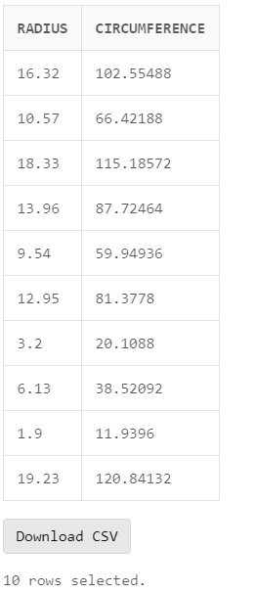

**2.Update the balance of each customer from a cust_acct table showing withdrawal of Rs.1000/-as service charge provided that the customer balance shows at least Rs.1000/-.**

**Query:**

Create table customer(

Customer_id number primary key,

Customer_name varchar(100),

Balance number

);

-- Insert sample data into the customer table

Insert into customer(Customer_id, customer_name, balance)

Values(1, 'Rohit', 1900);

Insert into customer(customer_id, customer_name, balance)

Values(2, 'Gill', 1400);

Insert into customer(Customer_id, customer_name, balance)

Values(3, 'Virat', 600);

Insert into customer(customer_id, customer_name, balance)

Values(4, 'KL Rahul', 3000);

Insert into customer(Customer_id, customer_name, balance)

Values(5, 'Surya', 1000);

Insert into customer(customer_id, customer_name, balance)

Values(6, 'Hardik', 999);

-- Update the balance of each customer from the customer table with a charge

Declare

Service_charge number := 1000;

Begin

Update customer

Set balance = balance - service_charge

Where balance >= 1000;

Commit;

End;

/

Select * from customer;

**Input:**

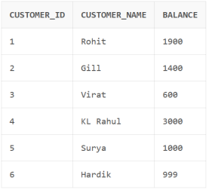

**Output:**

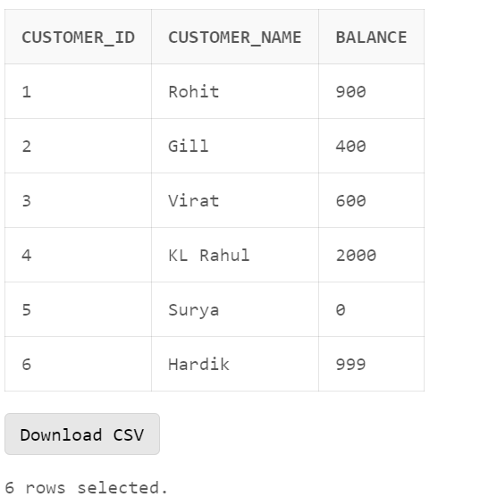

**3. Update the salary of each employee from EMP table by 15% using cursor.**

**Query:**

Create table emp(

Emp_id number primary key,

Emp_name varchar(100),

Salary number

);

-- Insert sample employee data into the emp table

Insert into emp(emp_id, emp_name, salary)

Values(901, 'Rohit', 900000);

Insert into emp(emp_id, emp_name, salary)

Values(902, 'Gill', 500000);

Insert into emp(emp_id, emp_name, salary)

Values(903, 'Virat', 1000000);

Insert into emp(emp_id, emp_name, salary)

Values(904, 'Rahul', 800000);

Select * from emp;

-- Update the salary of each employee from the emp table by 15% using a cursor

Declare

cursor emp_cursor is

Select emp_id, salary

From emp;

E_emp_id emp.emp_id%TYPE;

E_salary emp.salary%type;

Begin

For rec IN emp_cursor LOOP

E_emp_id := rec.emp_id;

E_salary := rec.salary;

-- Update salary by 15%

E_salary := E_salary * 1.15;

Update emp

Set salary = E_salary

Where emp_id = E_emp_id;

End LOOP;

Commit;

End;

/

Select * from Emp;

**Input:**

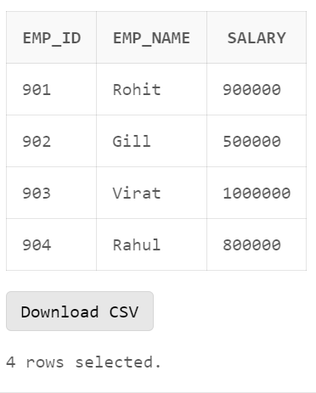

**Output:**

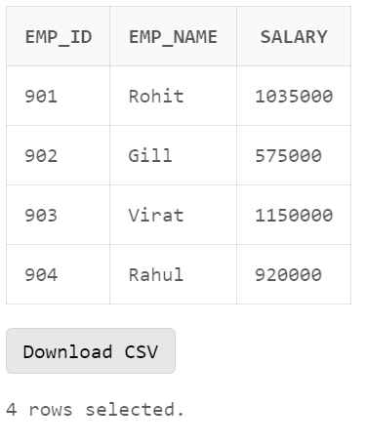

**4. Update the balance in the ITEM_MSTR table each time a transaction takes place in the ITEM_TR table. If the item_id is already present in the ITEM_MSTR table an update is performed to decrease the balance by the quantity specified in the ITEM_TR table.**

**IF the item_id is not present in the ITEM_MSTR table, the tuple is to be inserted.**

**Query:**

Create table item_mstr(

Item_id number primary key,

Balance number

);

--create the item_tr table to track transactions

Create table item_tr(

Transaction_id number primary key,

Item_id number,

Quantity number

);

--insert sample data into the item_mstr table

Insert into item_mstr(item_id,balance)

Values(1,500);

Insert into item_mstr(item_id,balance)

Values(3,400);

--insert sample transaction data into the item_tr table

Insert into item_tr(transaction_id,item_id,quantity)

Values(1,1,10);

Insert into item_tr(transaction_id,item_id,quantity)

Values(2,2,15);

Insert into item_tr(transaction_id,item_id ,quantity)

Values(3,3,25);

Select * from item_mstr;

Select* from item_tr;

--update the balance in the item_mstr table based on transactions in item_tr

Declare

T_item_id item_tr.item_id%type;

T_quantity item_tr.quantity%type;

Begin

For rec in(select item_id,quantity from item_tr)LOOP

T_item_id := rec.item_id;

T_quantity := rec.quantity;

--check if t_item_id already exists in item_mstr

BEGIN

Update item_mstr

Set balance = balance- t_quantity

Where item_id = t_item_id;

If sql%notfound then

Raise no_data_found;

End if;

Exception

When no_data_found then

--insert a new tuple in item_mstr if item_id is not found

Insert into item_mstr(item_id,balance)

Values(t_item_id,t_quantity);

End;

End LOOP;

Commit;

End;

/

Drop table item_tr;

/

Select* from item_mstr;

Drop table item_mstr;

/

**INPUT:**

Item_mstr:

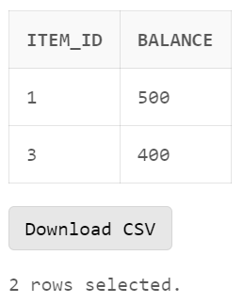

Item_Tr:

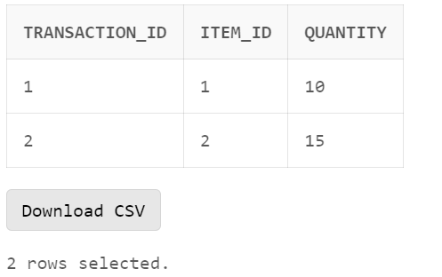

**Output:**

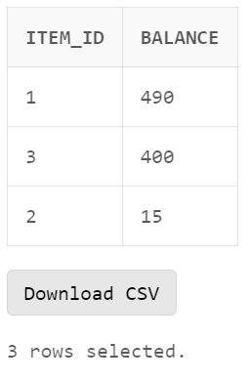

5. **Write a procedure for raising salary of some employee by some amount . The procedure to be written may carry two parameters emp_id and amt to be raised.Include two exceptions which will be raised when either emp_id is not present or salary is NULL.**

**Query:**

--Create the emp table for employee information

Create table emp(

Emp_id number primary key,

Emp_name varchar(100),

Salary number

);

--insert sample employee data into the emp table

Insert into emp(emp_id,emp_name,salary)

Values(901, ‘Rohit’,900000);

Insert into emp(emp_id,emp_name,salary)

Values(902, ‘Gill’,500000);

Insert into emp(emp_id,emp_name,salary)

Values(903, ‘Virat’ ,1000000);

Insert into emp(emp_id,emp_name,salary)

Values(904, ‘Rahul’,800000);

Insert into emp(emp_id,emp_name)

Values(905, ‘Shreyas’);

Select* from emp;

--create a procedure to raise the salary of an employee by a specified amount

Create or replace procedure raise_employee_salary(

E_id emp.emp_id%TYPE,

Amt number

)is

E_current_salary Emp.salary%TYPE;

BEGIN

--check if the employee exists and get their current salary

Select salary into e_current_salary

From emp

Where emp_id = e_id;

--raise the salary by the specified amount

If e_current_salary is NULL then

Raise_Application_error(-20001, ‘Employee salary is NULL’);

Else

Update emp

Set salary = e_current_salary +amt

Where emp_id =e_id;

Commit;

End if;

Exception

When no_data_found then

Raise_application_error(-20002, ‘Employee ID is not Valid.’);

End raise_employee_salary;

/

BEGIN

Raise_employee_salary(901,100000);

End;

/

Select*from emp;

/

--call where emp salary is currently NULL

BEGIN

Raise_employee_salary(905,50000);

End;

/

--call where emp_id is not in table

Begin

Raise_employee_salary(907,20000);

End;

/

Drop table emp;

/

**INPUT:**

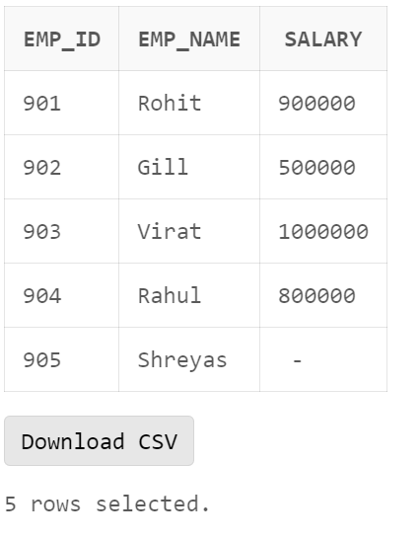

**Output:**

